**PRACTICAL: 6**

**NATIVE VIRTUALIZATION USING Hyper-V**

First we have to uninstall vmware software if already installed on computer because the VMware Workstation installer does not support running on a

Hyper-V virtual machine.

After uninstalling VMware, we can proceed to next step - go to control panel and click on uninstall a program

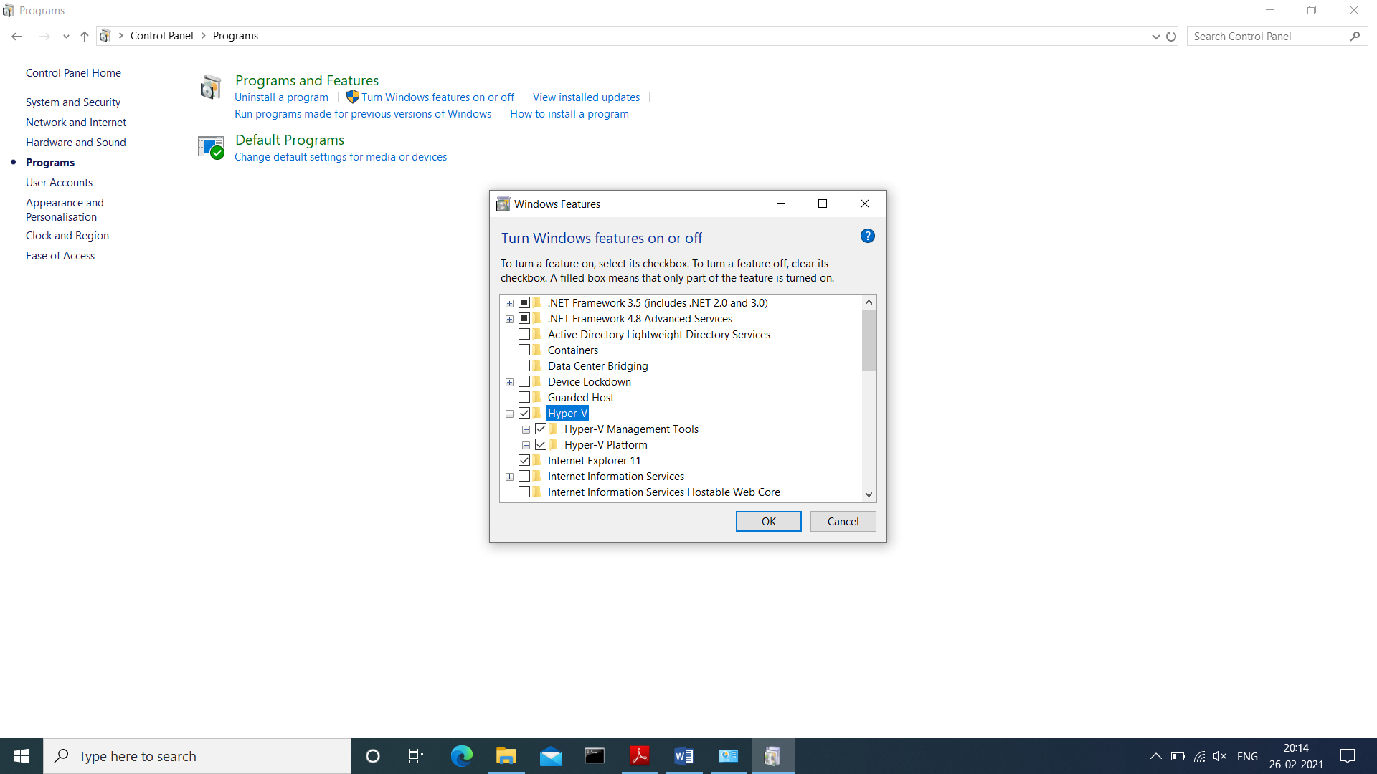

After Restart **Search for hyper-v manager in search box and click on that**

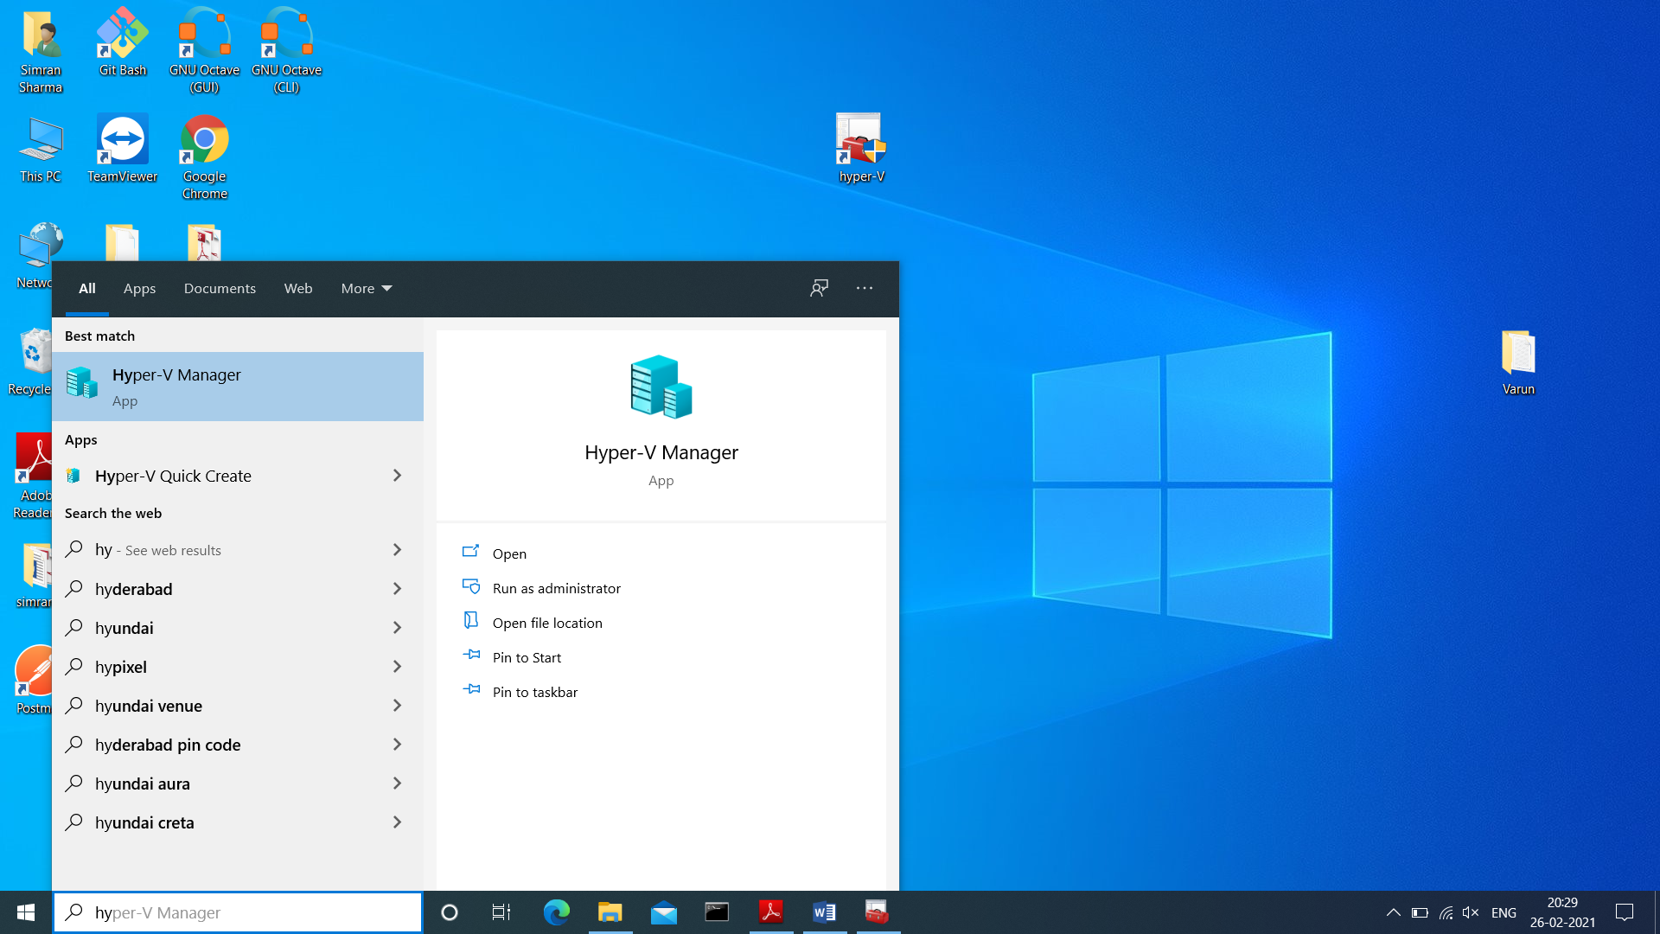

**for creating virtual machine first we have to create virtual switch**

click on virtual switch manager option

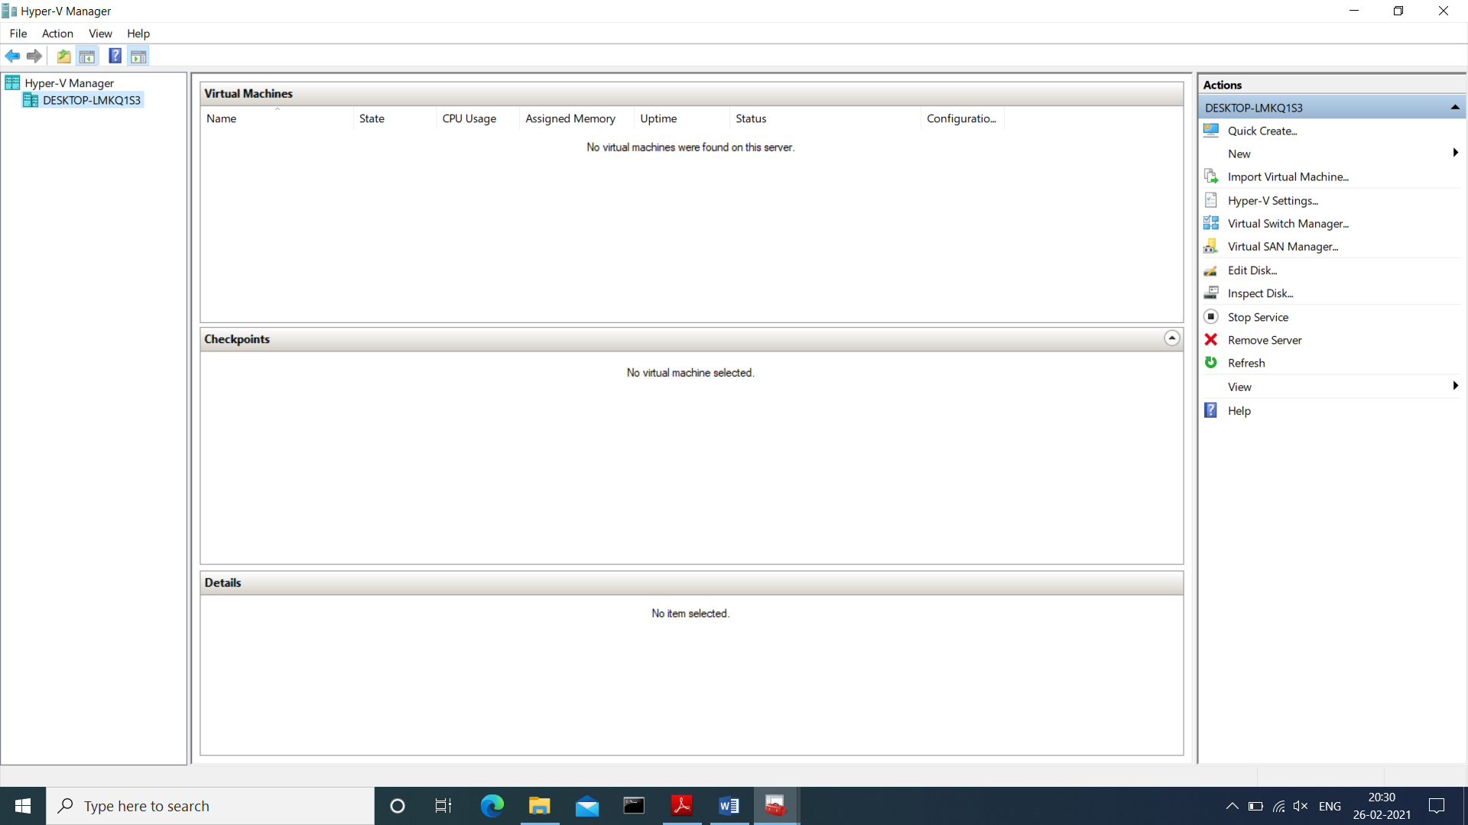

Select External as a connection type and then click on create virtual switch

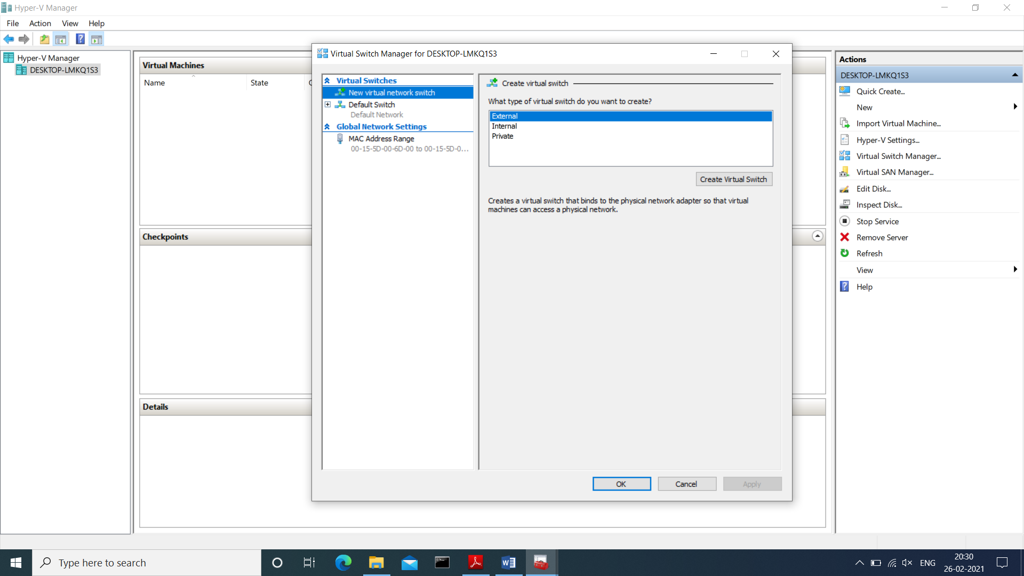

Give name to our virtual switch then click on apply button

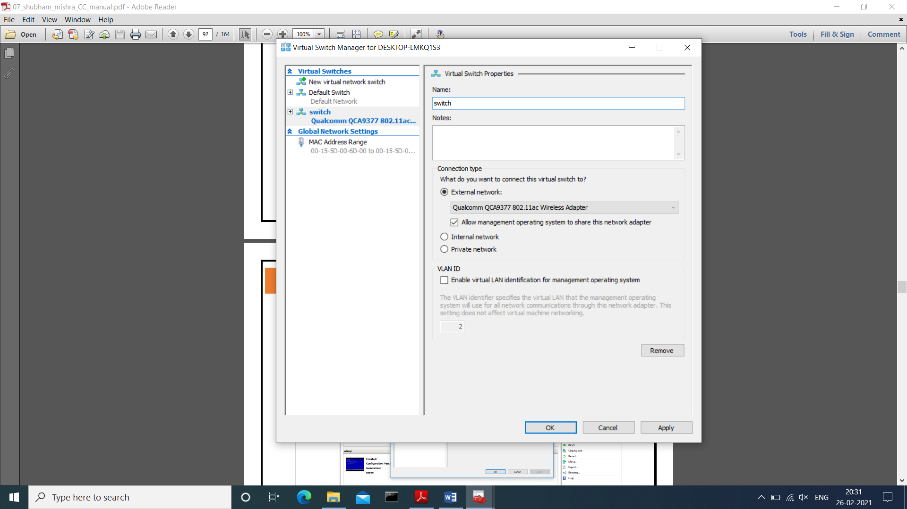

after click on Apply button it will show warning about our connection

click on yes

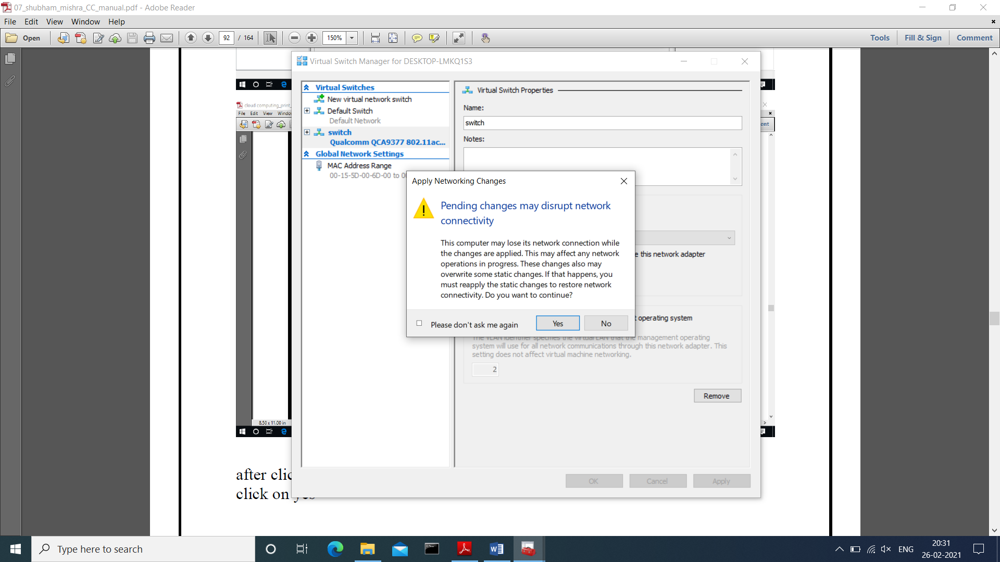

Now right click on server and select new virtual machine

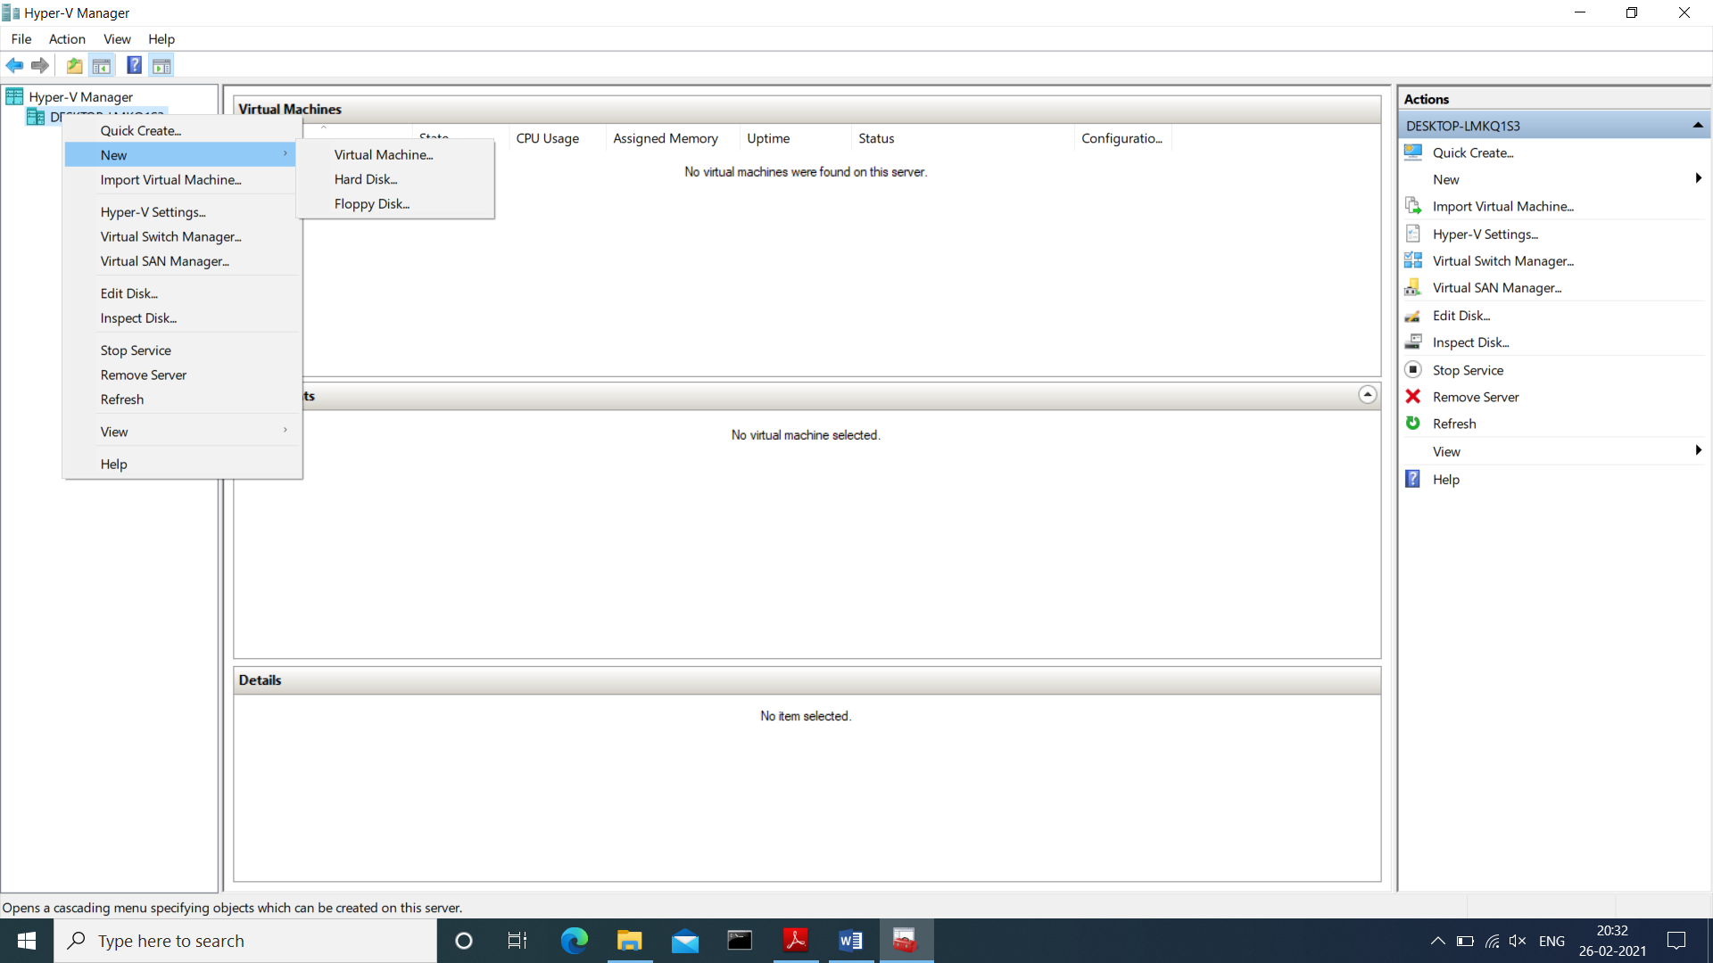

click on next button

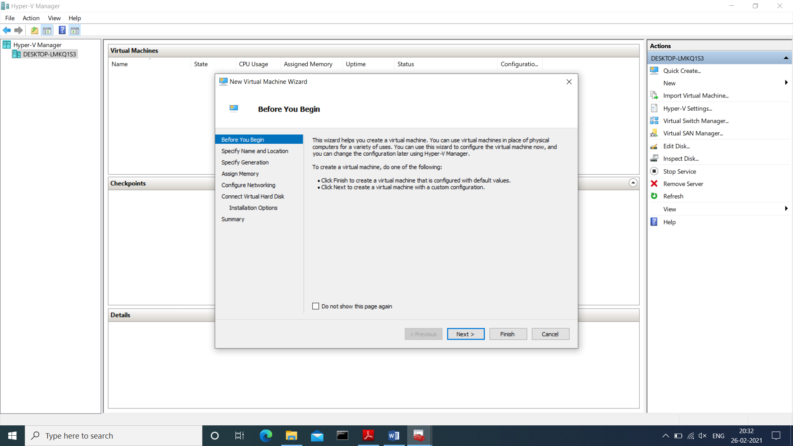

Provide name to virtual machine then click on Next button

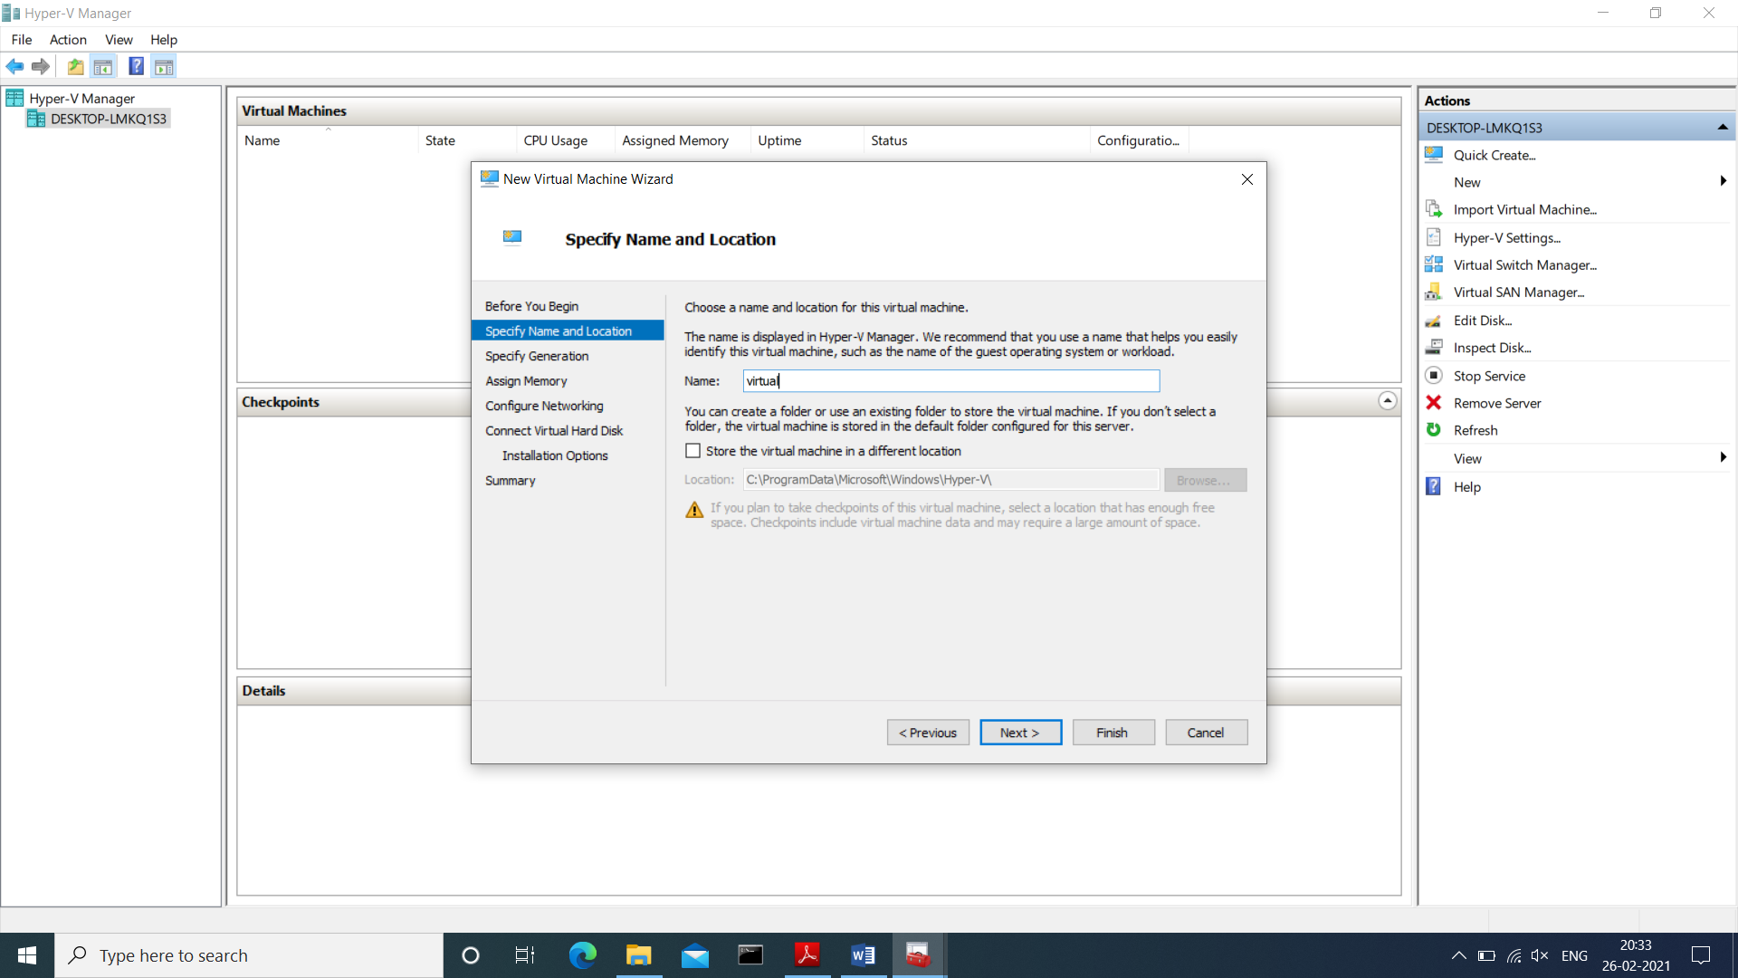

Specify generation : generation 1

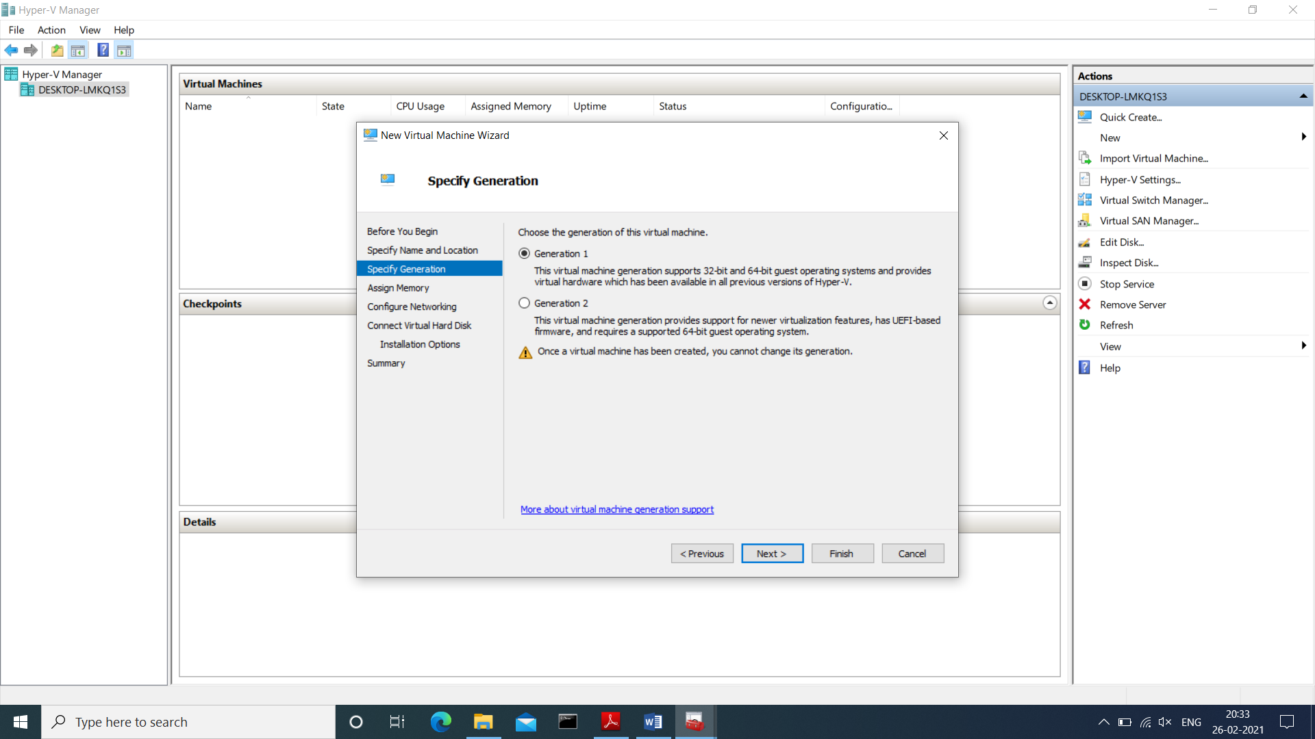

tick on use **dynamic memory for this virtual machine**

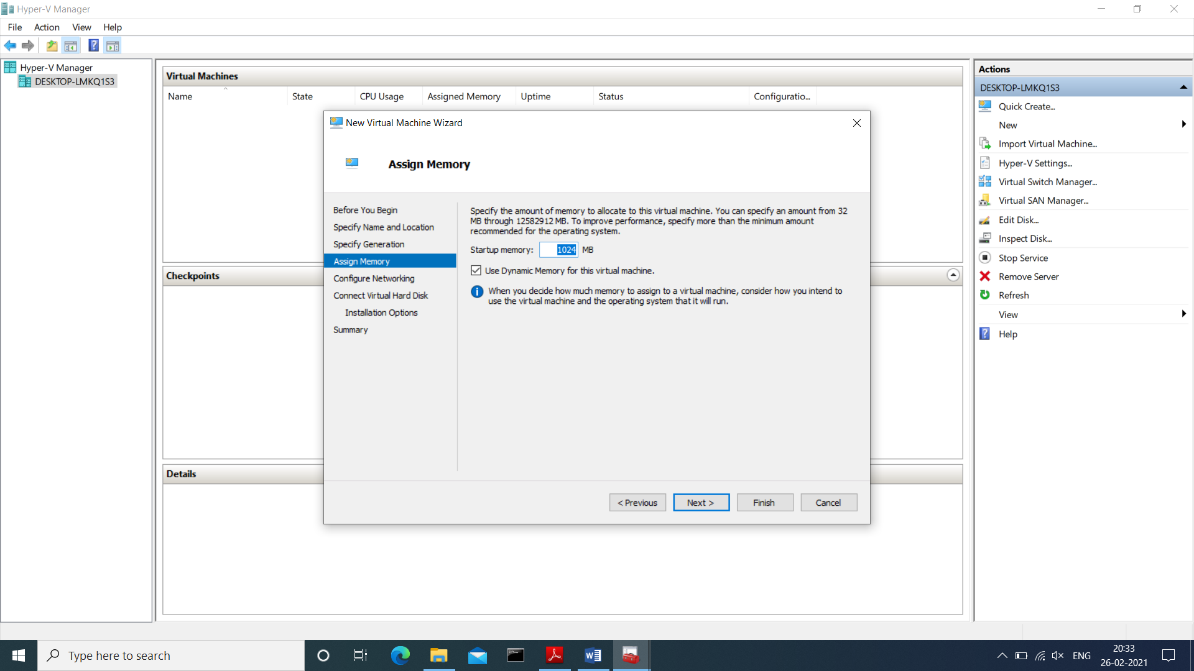

Select switch which we created earlier for our virtual machine from drop-down list and then click on next

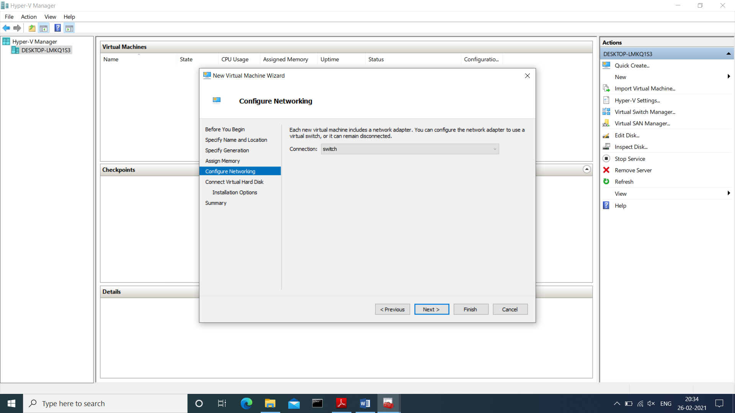

Description of virtual machine and location where it will store virtual machine related files and size require for this machine click on next

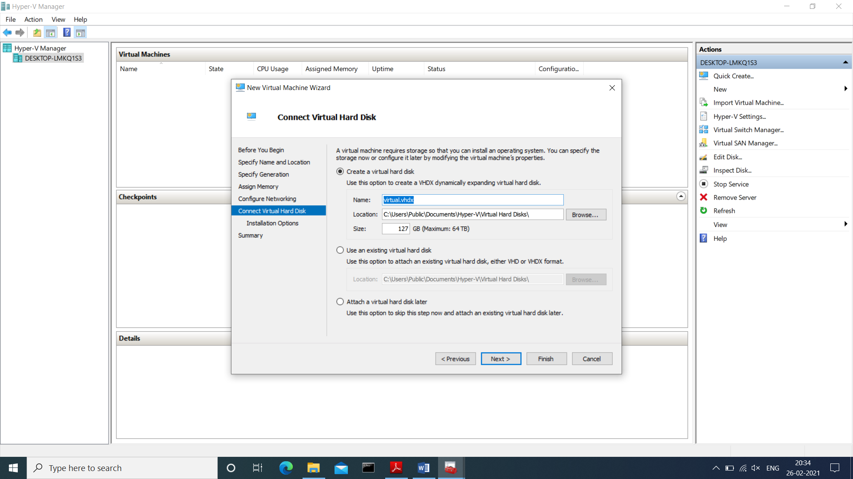

New virtual machine wizard panel will appear, where we will choose operating system which we want to install on virtual machine

select install an operating system from boot CD/DVD-ROM and then select Image file(.iso) and browse our OS iso file then click on next button

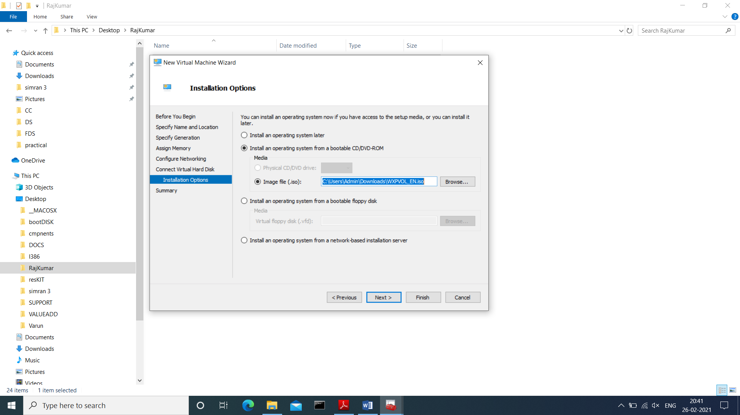

Summary report will be generated about virtual machine then click on Finish button

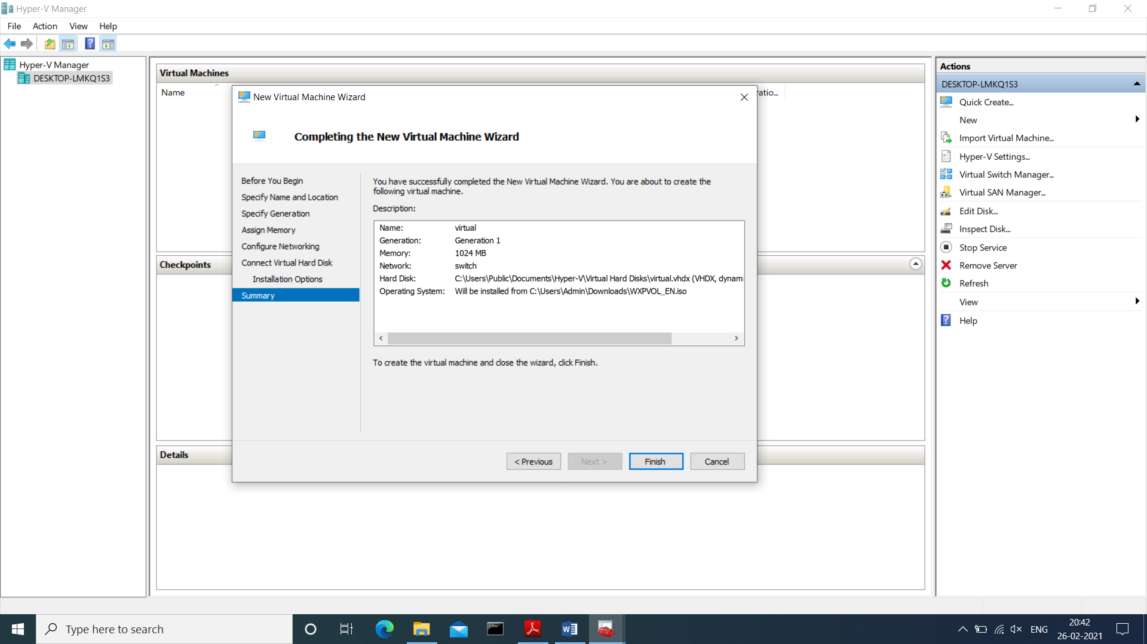

In virtual machine panel our virtual machine will appear which has off state

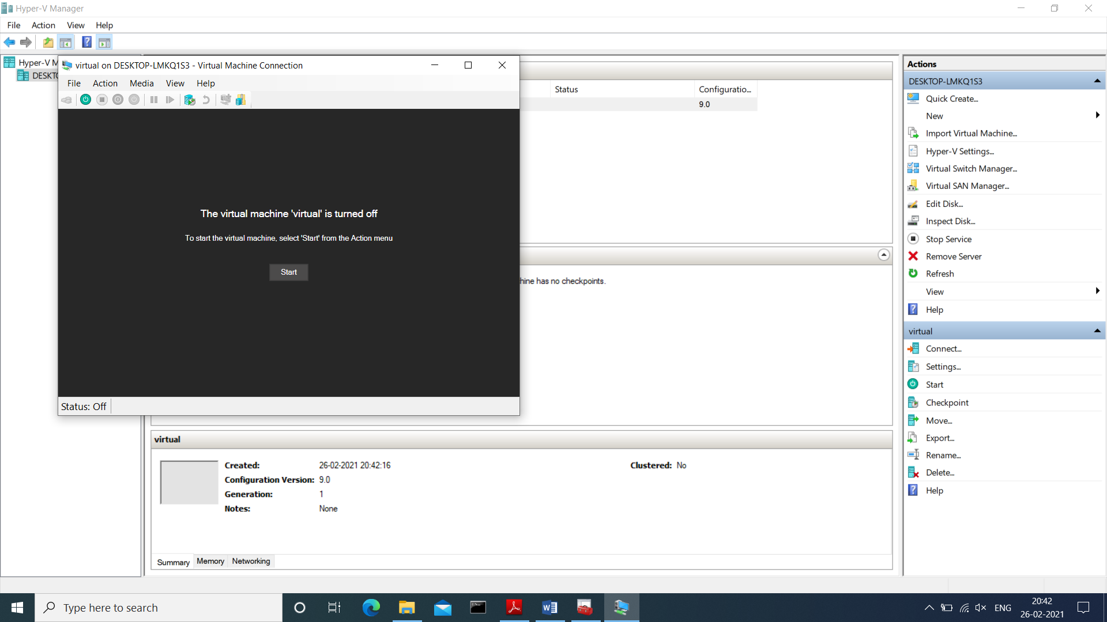

Right click on virtual machine and click on connect option

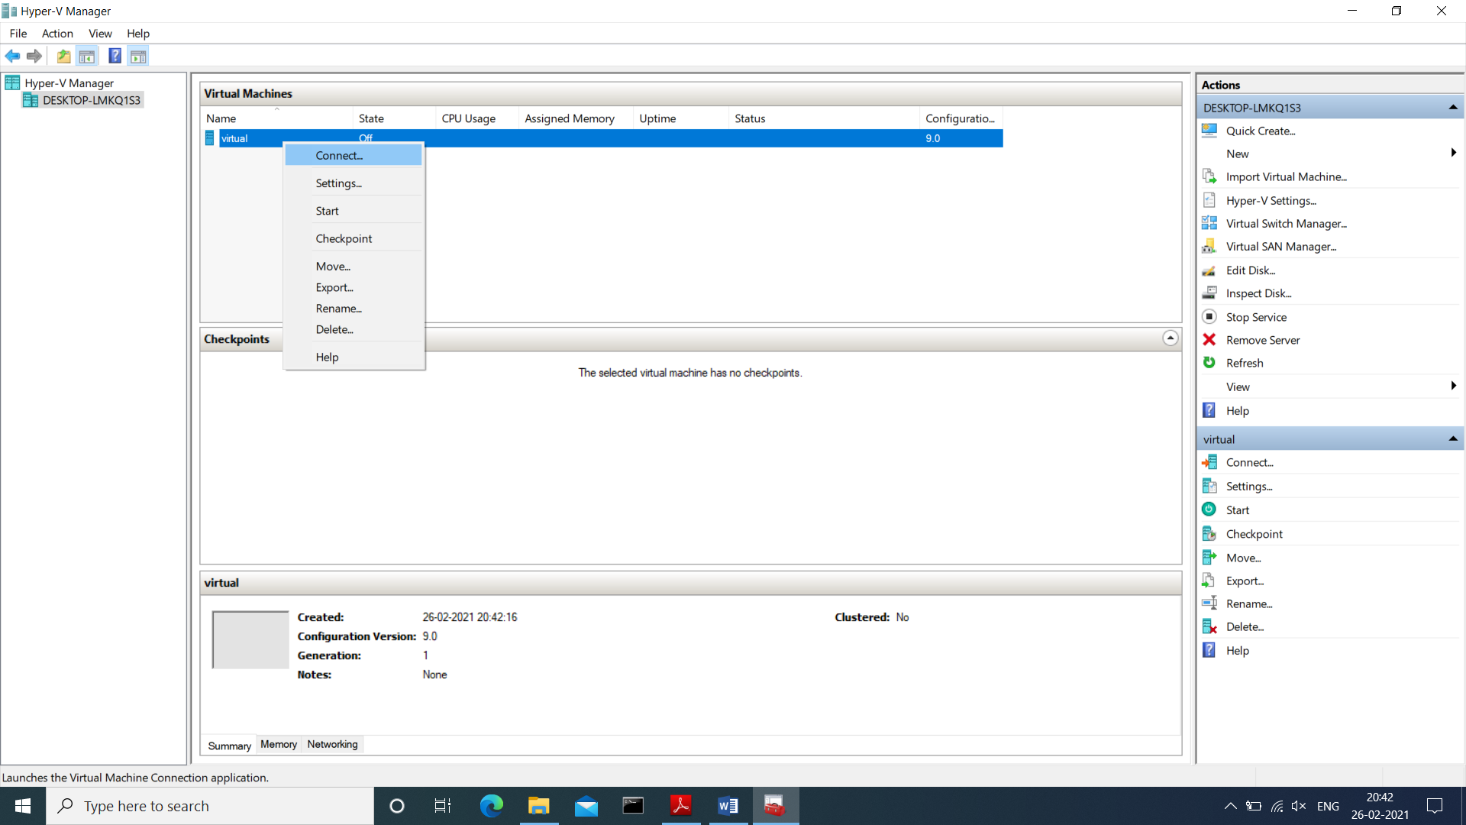

Virtual machine will start with below screen

